

**JOHNSON & JOHNSON Medical Middle East**

**Dubai, U.A.E.**

**Service and Repair Center**

**Approval for the 1000, 2100, 2100J, 2200, and 2200J**

**Product Codes**

**Factbook FB003285**



## Factbook Approval

We have reviewed and do approve Factbook FB003285, Addendum to Factbook FB002770 Rev A, for the service and repair of the Mega Power 1000 Generator, Mega Vac 2100 and 2100J, and Mega Vac+ 2200 and 2200J at Johnson & Johnson Medical Middle East, Dubai, U.A.E. We find that the documentation contained in this Factbook meets the requirements as defined by WE001534, Rev E, Establishment and Certification of Service Depot, Field Service, and Parts Depot Centers. The signoff of this Factbook represents the certification process and indicates the service center is to be considered authorized/qualified to perform service on the identified products.

E-Sig in Epi Center   E-Sig in Epi Center

___________________________________________ _______________________

Jamie Best Date

Manager, International Service Center

E-Sig in Epi Center   E-Sig in Epi Center

___________________________________________ _______________________

Robert Peters Date

Team Leader, Customer Quality

Worldwide Service and Repair



# FACTBOOK CHECKLIST

Date: 25-February-2019

From: Jason Stivers

Attention: Factbook FB003285 Re: 1000, 2100, 2100J, 2200, 2200J

|  |  |  |
| --- | --- | --- |
| **Activity** | **Complete** | **Not Applicable** |
| **Service System Quality Assessment** | **√** |  |
| **Technical Training Program** | **√** |  |
| **Documentation System** | **√** |  |
| **Equipment Installation Qualification (EIQ)** | **√** |  |
| **Physical Requirements** | **√** |  |
| **Operating Agreement** | **√** |  |
| **Start-Up Activities** | **√** |  |
| **Supplier Approval** | **√** |  |

Indicate Activity status with a single **“ √ “** mark.

E-Sig in Epi Center

Jason Stivers

Service Engineer, EES – Service Staff Engineer



# FACTBOOK STRATEGY

Date: 25-February-2019

From: Jason Stivers

Attention: Factbook FB003285 Re: 1000, 2100, 2100J, 2200, 2200J

The support data establishing Johnson & Johnson Medical Middle East, Dubai, U.A.E. as an Ethicon Endo-Surgery authorized service center for the 1000, 2100, 2100J, 2200, and 2200J MegaDyne capital equipment is contained in this Factbook.

The process used follows WE001534 Rev E, Establishment and Certification of Service Depot, Field Service, and Parts Depot Centers. A Service and Repair Facility Qualification Record has been created which serves as the index for this Factbook. Approval signatures will appear on each memorandum page as outlined by the Service and Repair Facility Qualification Record.

This information is an Addendum to the original Factbook FB002770 Rev A that qualified Johnson & Johnson Medical Middle East, Dubai, U.A.E. as an authorized service center for the GEN11. This Factbook documents the training and qualification to repair the product codes Mega Power 1000 generator, Mega Vac 2100 and 2100J, and Mega Vac+ 2200 and 2200J. Johnson & Johnson Medical Middle East, Dubai, U.A.E. was previously authorized to service GEN11 which is not affected by this Factbook.

E-Sig in Epi Center

Jason Stivers

Service Engineer, EES – Service Staff Engineer



**Service & Repair Facility Qualification Record**

The table of contents of this Factbook is listed below. The documentation contained meets the intent of WE001534 Rev E, Product Qualification at Service Centers.

|  |  |
| --- | --- |
| Section | Pg. |
| **1.0 Service System Quality Assessment** | 7 |
| 1.1 Reference Memorandum | 8 |
| **2.0 Technical Training Results** | 9 |
| 2.1 Training Results Memorandum | 10-11 |
| 2.1.1 Training Agenda | 12 |
| 2.1.2 Training log | 13 |
| 2.1.3 Train the Trainer | 14 |
| 2.1.4 Test records | 15-18 |
| 2.1.5 Training Certificate | 19 |
| **3.0 Documentation System** | 20 |
| 3.1 Documentation System Memorandum | 21 |
| **4.0 Equipment Installation Qualification (EIQ)** | 22 |
| 4.1 EIQ Results Memorandum | 23 |
| 4.1.1 Mega Vac Qualification Memo | 24 |
| 4.1.2 MegaPower 1000 Installation Qualification Test Protocol ENG-PRT-473 | 25-26 |
| 4.1.3 MegaPower 1000 Installation Qualification. ENG-PRT-473 Appendix A | 27-36 |
| 4.1.4 MegaPower 1000 Performance/Operational Qualification Test Protocol ENG-PRT-502 | 37-38 |
| 4.1.5 MegaPower 1000 Service Center Protocol Results | 39-49 |
| 4.1.6 MegaVac Installation Qualification Test Protocol ENG-PRT-475 | 50-51 |
| 4.1.7 MegaVac Installation Qualification ENG-PRT-475 Appendix A | 52-53 |
| 4.1.8 MegaVac Plus Installation Qualification Test Protocol ENG-PRT-476 | 54-55 |
| 4.1.9 MegaVac Plus Installation Qualification ENG-PRT-476 Appendix A | 56-57 |
| 4.1.10 MegaVac Plus Performance/Operational Qualification Test Protocol ENG-PRT-503 | 58-59 |
| 4.1.11 MegaVac Plus Service Center Protocol Results | 60-61 |
| 4.1.12 Calibration Certificate – Fluke QA-ES II ESU Analyzer | 62-63 |
| 4.1.13 Calibration Certificate – Fluke 289 Digital Multimeter | 64-66 |
| 4.1.14 Calibration Certificate – Bio-Tek 601 Pro Series 1 Safety Analyzer | 67-68 |
| 4.1.15 Calibration Certificate – TSI 4040H Flow Meter | 69-70 |
| 4.1.16 Calibration Certificate – Dwyer 477AV Manometer | 71-72 |
| 4.1.17 Specification sheet – Fluke QA-ES II ESU Analyzer | 73-76 |
| 4.1.18 Specification sheet – Fluke 289 Digital Multimeter | 77-78 |
| 4.1.19 Specification sheet – Bio-Tek 601 Pro Series 1 Safety Analyzer | 79-84 |
| 4.1.20 Specification sheet – TSI 4040H Flow Meter | 85-88 |
| 4.1.21 Specification sheet - Dwyer 477AV Manometer | 89-90 |
| **5.0 Physical Requirements** | 91 |
| 5.1 Reference Memorandum | 92 |
| 5.1.1 Work area/building layout | 93 |
| **6.0 Operating Agreement** | 94 |
| 6.1 Reference Memorandum | 95 |
| 6.2 Quality Agreement | 96-112 |
| **7.0 Start-Up Activities** | 113 |
| 7.1 Reference Memorandum Start up Activities | 114 |
| **8.0 Supplier Approval** | 115 |
| 8.1 Reference Memorandum Supplier Approval | 116 |

**1.0 SERVICE SYSTEM QUALITY ASSESSMENT**



# SERVICE SYSTEM QUALITY ASSESSMENT

Date: 25-February-2019

From: Jason Stivers

Attention: Factbook # FB003285 Re:1000, 2100, 2100J, 2200, & 2200J

Refer to section 1.0 of Factbook FB002770 REV A for the support documentation that a servicing quality system assessment was conducted according to established procedures. Ongoing quality assessments of this facility will be maintained on file in EtQ per schedule. The last onsite audit of Johnson & Johnson Medical Middle East, Dubai, U.A.E., was conducted on January 11, 2016, audit # SA-010180.

E-Sig in Epi Center

Jason Stivers

Service Engineer, EES – Service Staff Engineer

**2.0 TECHNICAL TRAINING RESULTS**



# TECHNICAL TRAINING RESULTS

Date: 25-February-2019

From: Jason Stivers

Attention: Factbook # FB003285 Re:1000, 2100, 2100J, 2200, & 2200J

On December 12, 2017 five (5) service technicians from various EES approved service centers were provided training at the J&J Singapore service and repair facility (central location for attendees, but not an EES service center) for the following products:

* 1000, Mega Power Generator
* 2100 and 2100J, Mega Vac Smoke Evacuator
* 2200 and 2200J, Mega Vac Plus Smoke Evacuator

The training was conducted and overseen by MegaDyne Service and Repair Trainers John Minuth and Bruce Hevelone. Training began with a basic introduction to the product application and use, theory of operation of the system and a general product description and functional description. The attached training log contains the list of MegaDyne forms, work instructions, software, and service bulletins required to be covered during the training for product codes. Additionally, procedures/manuals that included disassembly, reassembly, repair, testing, quality inspection, and product release were covered in the training. Troubleshooting information was also covered, which included identifying common causes of failure, hardware troubleshooting, and service testing. Afterward, standard service center processes, such as bench tests, electrical safely tests, and product release tests were demonstrated. To demonstrate the ability to repair the products the trainee was provided and passed a written test post training. Finally, complaint awareness training is conducted on an annual basis and thus was not a needed deliverable for this specific training. Training records for complaint awareness are maintained within the training management system at J&J Medical Spa Mumbai, India and reviewed during annual business reviews.

With this successful completion of the activities referenced above, the following individual(s) should now be considered trained as an authorized EES representative capable of the analysis, service, and repair of the MegaDyne products listed above, and as a qualified and authorized trainer for the product. Additionally, with this successful completion of the activities referenced above, the following individual(s) should now be considered trained as an authorized EES representative capable of the final release of product to inventory and authorized to train the quality release person(s) within their center.

1. Amer Nehlawi, Service Technician

Evidence of completion of these activities is:

* MegaDyne Training Record Form
* Training Log
* Training Agenda
* MegaDyne Training Test Results
* Certificate of Training

E-Sig in Epi Center

Jason Stivers

Service Engineer, EES – Service Staff Engineer

**3.0 DOCUMENTATION SYSTEM**



# DOCUMENTATION SYSTEM

Date: 25-February-2019

From: Jason Stivers

Attention: Factbook # FB003285 Re: 1000, 2100, 2100J, 2200 & 2200J

The following procedures include 1000, 2100, 2100J, 2200, and 2200J MegaDyne capital equipment service processes at the service center. The procedures can be found within the Johnson & Johnson Medical Middle East, Dubai, U.A.E. LTD, documentation system as follows:

Process Specifications/Procedures:

MEEP-Technical Services-General Operations SOP (TV-SOP-16516 Ver 3.0)

Procedures, work instructions, and items that are non-product specific to 1000, 2100, 2100J, 2200, and 2200J already reside in the Johnson & Johnson Medical Middle East, Dubai, U.A.E. documentation system as they were previously qualified as a service center. Refer to section 3.0 of Factbook FB002770.

E-Sig in Epi Center

Jason Stivers

Service Engineer, EES – Service Staff Engineer

**4.0 EQUIPMENT INSTALLATION QUALIFICATION RESULTS**



### EIQ RESULTS

Date: 25-February-2019

From: Jason Stivers

Attention: Factbook FB003285 Re:1000, 2100, 2100J, 2200, & 2200J

All equipment necessary to perform service and repair activities on the 1000, 2100, 2100J, 2200, and 2200J have been installed at the Johnson & Johnson Medical Middle East, Dubai, U.A.E. location using local qualification procedure TV-SOP-03387, Installation and Servicing and MegaDyne Medical Products, Inc. protocols ENG-PRT-473, ENG-PRT-475, ENG-PRT-476, ENG-PRT-502, and ENG-PRT-503.

As described in the service procedures, the product specific test equipment used for the repair and testing of the 1000, 2100, 2100J, 2200, and 2200J is as follows:

* Fluke QA-ES II ESU Analyzer
* Fluke 289 Digital Multimeter
* Bio-Tek 601 Pro Series 1 Safety Analyzer
* TSI 4040H Flow Meter
* Dwyer 477AV Manometer

Johnson & Johnson Medical Middle East, Dubai, U.A.E. personnel were trained and qualified to use the above-mentioned equipment as referenced in the training section of this Factbook.

The equipment can be found within the Johnson & Johnson Medical Middle East, Dubai, U.A.E. calibration system where appropriate and custom tooling or equipment identified has been documented as installed for use. Installation qualification of equipment was performed as passing a known “good” unit through the process. The attached documents represent the successful execution of test procedures which qualifies the test equipment being used as properly installed and in good working order.

Part of product testing includes performing electrical safety testing according to appropriate standards as outlined in the service documentation and service bulletins (if applicable). The equipment used at Johnson & Johnson Medical Middle East, Dubai, U.A.E. meets all applicable standards.

E-Sig in Epi Center

_________________________

Jason Stivers

Service Engineer, EES – Service Staff Engineer

**5.0 PHYSICAL REQUIREMENTS**



### PHYSICAL REQUIREMENTS

Date: 25-February-2019

From: Jason Stivers

Attention: Factbook # FB003285 Re:1000, 2100, 2100J, 2200, & 2200J

Refer to Attachment for the support documentation that Johnson & Johnson Medical Middle East, Dubai, U.A.E. has the necessary physical requirements to provide adequate space for the service and repair of the 1000, 2100, 2100J, 2200, and 2200J. See attached floor layout.

The service center meets the electrical power requirements and has separate work spaces for product receiving/shipping, decontamination, service area, and electrical safety.

E-Sig in Epi Center

_________________________

Jason Stivers

Service Engineer, EES – Service Staff Engineer

**6.0 OPERATING AGREEMENT**



### OPERATING AGREEMENT

Date: 25-February-2019

From: Jason Stivers

Attention: Factbook FB003285 Re:1000, 2100, 2100J, 2200, & 2200J

EES and JOHNSON & JOHNSON Medical Middle East (Dubai, U.A.E.) have entered into an operating agreement. The Operating Agreement is located in International Contract Database (e-ICD # 1270220).

Additionally, JOHNSON & JOHNSON Medical Middle East (Dubai, U.A.E.) have entered into a quality agreement with Ethicon Endo-Surgery, LLC. The most recent version of that agreement is in Adaptive under #100572048.

E-Sig in Epi Center

_________________________

Jason Stivers

Service Engineer, EES – Service Staff Engineer

**7.0 START-UP ACTIVITIES**



### START-UP ACTIVITIES

Date: 25-February-2019

From: Jason Stivers

Attention: Factbook FB003285 Re:1000, 2100, 2100J, 2200, & 2200J

Refer to section 7.0 of FB002770 Rev A for the support documentation that all activities were previously established in accordance with WE000650 Rev G. The current activities for the establishment of 1000, 2100, 2100J, 2200, and 2200J product codes are in accordance with WE001534 Rev E.

In accordance with WE001534 Rev E, the following start-up activities have taken place to prepare

Johnson & Johnson Medical Middle East, Dubai, U.A.E. to begin service and repair on 1000, 2100, 2100J, 2200, and 2200J.

• Spare parts needed to perform repairs will be made available upon Factbook approval

• The linkage to the Complaint Management/Service System has been established. The service center has been using the process for the routing of all service data to the Complaint Management/Service System, and will include 1000, 2100, 2100J, 2200, and 2200J reporting as well.

• Equipment required to perform repairs and testing has been purchased and properly installed

• The service center has been made aware of the requirements for repair tracking and expediting

through the repair center and monthly reporting requirements.

* Products have been added to the monthly reporting process
* Product related service bulletins have been delivered and implemented

E-Sig in Epi Center

Jason Stivers

Service Engineer, EES – Service Staff Engineer

**8.0 SUPPLIER APPROVAL**



### 

### Supplier Approval

Date: 25-February-2019

From: Jason Stivers

Attention: Factbook FB003285 Re:1000, 2100, 2100J, 2200, & 2200J

Reference DOC000661 in Epi Center for supporting documentation that established Johnson & Johnson Medical Middle East, Dubai, U.A.E. as an authorized supplier. The service center will be maintained on the approved supplier list according to WE0652, Monitoring/Communication with Service Centers and Parts Depots. A snapshot of the Corporate Approved Supplier List is below showing Johnson & Johnson Medical Middle East, Dubai, U.A.E. as currently being approved as of Feb 22, 2019.

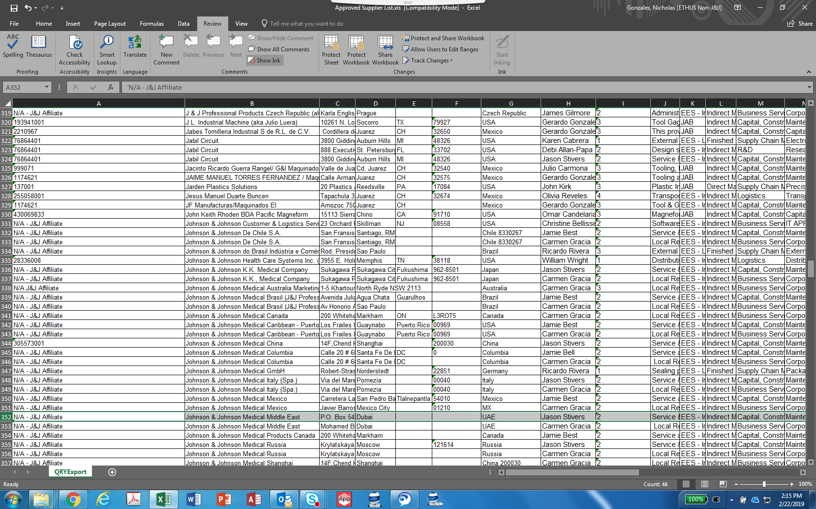

E-Sig in Epi Center

Jason Stivers

Service Engineer, EES – Service Staff Engineer